Event Health & Safety Plan Template

How to use this event operation health and safety plan template
As an event organiser, you are responsible for planning and managing risk at your event. This event operation plan template is provided to assist you to plan and deliver a safe, healthy and operationally successful event. This will be an evolving document that will be used to explain the operations involved in your event.
The template has been developed to reflect expectations for the management of risk at events and should be populated in consultation with WorkSafe NZ event safety guidelines.
This template suggests format, wording and content tailored to your event scale, nature and complexity as described in your event application form. You are responsible for identifying additional content, editing wording to reflect your management approach and adding any and all information critical to your event operations under the Health and Safety at Work Act 2015 (HSWA).
Notes before you start:
- This template is a suggested tool for your reference and use, reflecting South Waikato District Council’s expectations of an event operations plan. You are welcome to develop your own documentation should you choose not to use this template.

- The event safety guide should be used as a reference point on the level and type of information required within this or any other health and safety documentation.
- Grey text indicates where specific event information must be tailored.
- Sample information is placed throughout the template for reference only and should be deleted and replaced with information specific to your event.

Contents
Purpose 3
Event Details 3
Event Personnel & Contacts 4
Event Risk Assessment & Management Plan 4
Evaluate the Risks 4
Core Provisions and Communications 8
Event Day Incident Procedure 9
Inductions 10
Crowd Management 10
Evacuation Plan 10
Noise 10
Alcohol Management 10
Traffic and Transport 10
Traffic Management Plan 10
Parking 11
Food Vendors 11
Lighting 11
Power 11
Marquees 11
Information Tent 11
Waste Management 12
Amusement Devices 12
Contractor Management 12
Event Organiser Contractor Responsibilities 12
Contractor Responsibilities 12
Contractor List 13
Inductions 13
Lost Child Procedures 13
Lost Children Management Plan 13
Lost Child Centre 13
Communication 13
Staffing 14
Procedure 14
Appendices 14
Forms 15
Lost Child Form 15
Site Induction Check List 16
Event Day (Incident/Issue) Log 18
Accident Investigation Form 19
First Aid Register 20
Trained First Aid Register 21
Volunteer Briefing Sheet 22
Volunteer event day check in and out sheet 23
Event Insurance Certifications, Event Approval, Relevant Licenses 24

Purpose
This document outlines how ORGANISATION NAME OR INDIVIDUAL’S NAME plans to take all practicable steps to deliver a safe and therefore enjoyable event experience at EVENT NAME, DATE AND LOCATION.
WE/I understand and accept that under the Health and Safety at Work Act 2015 (HSWA), ORGANISATION/OR ORGANISER NAME, have at all times a duty of care to ensure the health and safety of all event participants and spectators, event staff, contractors, subcontractors, volunteers, other event delivery participants such as sponsors, and any persons legally entitled to be at or in the vicinity of the event site.
Name:

Role:

Date:

Signature:

Event Details
Event Name:
This Plan Dated:
Event Location
Event Date
Organisation delivering event
Number of Participants
Event Description

Event Personnel & Contacts
Name | Role | Responsibility | Contact Details

Event Risk Assessment & Management Plan
To plan for a safe and successful event and meet health and safety duties, risks that arise from the event must be effectively managed. As the event organiser we are aware that risks to health and safety arise from people being exposed to hazards.
Hazard = anything that could cause harm,
Risk = the potential harm caused by the hazard.
The risk control plan describes:
- All known event risks including during pack in and out,
- How they are being managed (eliminated or minimised),
- Who is responsible for managing the risk, and
- How it is used as a daily hazard check list.

Evaluate the Risks

Likelihood of Risk
This is not an exact science and can change depending upon changers in weather etc. etc.
- Almost Certain – the risk has a 90%+ likelihood of happening
- Likely – the risk incident has a 70-89% likelihood of occurrence
- Moderate – the risk incident has a 30-69% likelihood of happening
- Unlikely – the risk has a 5-29% likelihood of happening
- Rare – the risk has less than a 5% likelihood of happening

Impact of Risk
Extreme – Death, brain/spinal injuries, serious organ damage, permanent disability, emergency medical assistance, hospital for 6+ weeks
Major – Fractures, crush injuries, serious facial injuries, recovery of 6+ weeks, emergency medical assistance, hospital care
Moderate – Dislocation/simple fractures of ribs/limbs, medical assistance on site/at hospital/at GP, participant does not continue event, recovery of 1-6 weeks
Minor – Contusions, sprains, lacerations, minor first aid, participant continues event, less than 1 week’s recovery
Insignificant – Bruises, grazes, participant continues event, no recovery time or medical assistance
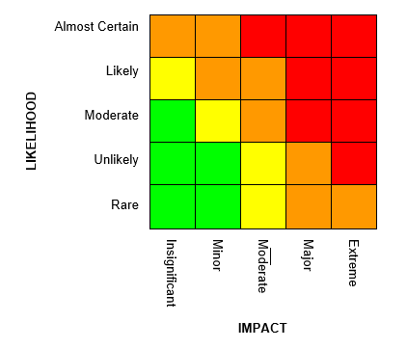

Overall Risk Level
Use the above risk matrix to determine the overall level of risk for each risk. Plot the likelihood and the risk impact and identify where they intersect.
- Red = critical risk
- Orange = high risk
- Yellow = moderate risk
- Green = low risk
If there are a large proportion of critical risk levels, then revisit your controls and re-assess to see if there are other ways to minimise risk.
Fill in Column ‘Overall Risk Level’ on the table.

Identify Controls for Each Risk
Some risks may be too great without action being taken to reduce them thus making them more acceptable. In considering all unacceptable risk, your options are to:
- Eliminate - Can the risk be removed
- Substitution/ Isolation - whether the risk could be replaced by one posing less risk, or can Isolating the hazard can prevent people coming into contact with it
- Engineering control - Apply physical control measures to minimise risk
- Administrative controls - If engineering controls are not sufficient to remove the risk, you are required to apply processes to make it safer.
- Personal protective equipment (PPE) - If the risk remains after all other measures have been applied, you must supply and ensure the use of personal protective equipment.
Fill in columns ‘level of controls’ on the table and describe how you will prevent.

Event Hazard Identification and Risk Assessment
Hazard or Risk identified. | Overall Risk Level | Level of Control  (see previous page) |  |  |  |  | Action
What could go wrong? | Low  Mod  High  Critical | Eliminate | Substitute | Engineer control | Admin Control | PPE | How will we prevent it? | Person responsible | What we will do if it happens?
Sunstroke or heat exhaustion | Mod | no | no | yes | yes | yes | Proper clothing / hat  Sunscreen / sun block  Event schedules  Shade provided at multiple sites | Event Manager | Refer to onsite first aid

Core Provisions and Communications
Core Provisions: Please give details of the following core provisions as they apply to your event or state NA if they do not apply
Item. | Provider | Person Responsible | Contact | Management Notes
First Aid and Medical services
Food
Shade
Toilets
Event Security
Waste Management
Spectator Controls
Parking

Event Day Incident Procedure
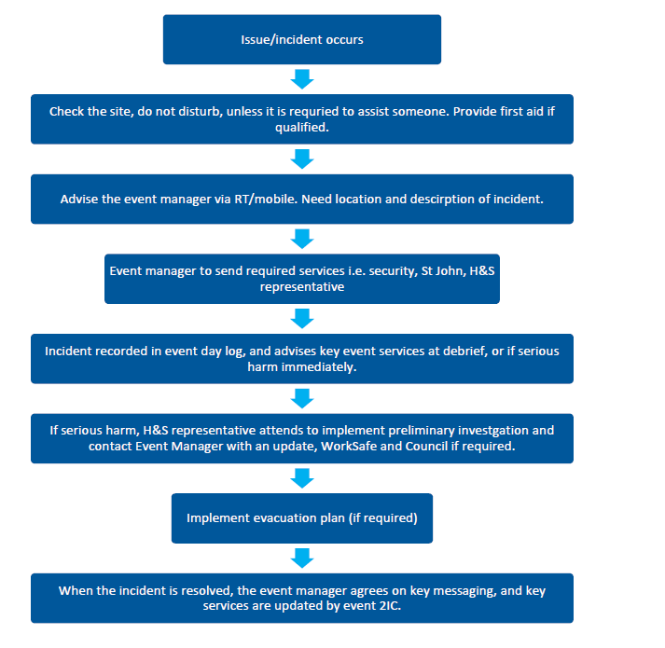
(SAMPLE: Delete and develop your own if the below is not relevant to your event.)

Inductions
EVENT ORGANISER will provide pre-briefings and onsite inductions to the above contractors to ensure H&S information is clearly communicated. Records of inductions will be maintained of who has been inducted to this plan.

Crowd Management
DESCRIBE ANTICIPATED CROWD e.g. crowd demographics, expected peak times for capacity crowds, any previous crowd issues i.e. behaviour.
DESCRIBE CROWD COMMUNICATIONS PLAN e.g. agreed messaging that will be given by the stage/security/event crew in the case of different crowd issues such as when crowd is almost at capacity and how these messages be given (loud hailers/PA system/stage mics).
DESCRIBE HOW EVACUATION COMMUNICATIONS WILL BE IMPLEMENTED i.e. link with evacuation plan.

Evacuation Plan
DESCRIBE HOW EVACUATION will be managed if an incident occurs that is significant, the evacuation of the event site will be agreed between the event manager, event H&S and relevant other parties as required.
INSERT VENUE EVACUATION PLAN – site map with egress points, crowd flows, muster point and an overview on how this will be managed and communicated.

Noise
DESCRIBE HOW THE EVENT WILL MANAGE NOISE LEVELS/RESTRICTIONS i.e. monitoring at sound desk, comment on any decibel levels that may apply to the event location or resource consent conditions, describe any personal protective equipment required by event crew/contractors and who is providing and monitoring use.

Alcohol Management
DESCRIBE ALCOHOL MANAGEMENT APPROACH
Is alcohol being allowed, supplied or sold and if so who is supplying when, license number, who has approved this and under what terms e.g. alcohol will be managed in accordance with the attached alcohol management plan. This plan has been reviewed and approved by South Waikato District Council as part of our liquor licence application.

Traffic and Transport

Traffic Management Plan
The event traffic management plan has been reviewed and approved by South Waikato District Council’s transport team.
Overview of traffic management: Explain why and what, and who the contractor is.
Road closures: E.g.: Smith Street (between Brown Street and White Road) from 2pm to 8pm on Saturday, 22 June 2018.

Parking
Please describe parking options and how it will be managed, If the parking options are full, how will this be this will be communicated.
DESCRIBE PROCESS TO ACTIVATE CONTINGENCY SITES e.g. Contingency sites will be opened, and event crew / security will advise attendees on the ground.

Parking Restrictions
For full plan see appendices. INSERT TRAFFIC MANAGEMENT PLAN

Food Vendors
The following food vendors will provide the current certificate, insurances and relevant food safety documentation.
Company name | Food description | Site location | Food safety license no.

Lighting
Contractor: INSERT NAME
DESCRIBE SERVICES - comment on any lux levels that may apply to the event location (resource consent conditions)

Power
Contractor: INSERT NAME
DESCRIBE SERVICES – tagged and tested, generators

Marquees
Contractor: INSERT NAME
DESCRIBE marquee dimensions, how being secured (pegging/weights). Show on site map.

Information Tent
Location: DESCRIBE LOCATION
Staffing: DESCRIBE WHO WILL STAFF
Provides: DESCRIBE STAFF ROLES e.g. provides event programmes, lost child forms, first aid kit, lost/ and found property.

Waste Management
DESCRIBE PROCESS for managing waste associated with the event ie who will be responsible for the maintenance and management of rubbish disposal together with facility cleanliness on an hourly basis or when demand requires it.

Amusement Devices
All mechanical devices used at the event will hold Worksafe certification and obtain a licence
to operate from Council. Land-borne inflatables (bouncy castles etc.) will operate in accordance with the Worksafe land-borne inflatable device operating requirements.
See https://worksafe.govt.nz/about-us/news-and-media/land-borne-inflatable-device-operating-requirements/
Where required, Council will be provided with appropriate health and safety documentation for relevant amusement devices.
Company name | device description | Device Serial Number | Certification No. | Specific H&S Requirements

Contractor Management
The event recognises that contractors and the event management company are a PCBU (person conducting a business or undertaking) under the HSWA.

Event Organiser Contractor Responsibilities
EVENT ORGANISER commits to undertaking the following actions at EVENT NAME to support delivery of a safe event environment; or where harm occurs, effective management of the occurring incident by:
- Reviewing all contractors’ event specific health and safety management plans prior to any works taking place and accepting the level of risk management associated with their works
- Site inductions for all contractors including event overview, on site hazards, H&S reporting and investigation processes, location of facilities (toilets, water) (refer to induction check list)
  - EVENT ORGANISER is taking a contractor induction: WHERE AND WHEN
- Onsite monitoring of contractor activity in line with contractor’s event specific H&S plans (pack in/out and event day)
  - EVENT ORGANISER is monitoring contractors when on site
- Providing post event feedback to inform future planning and documentation.

Contractor Responsibilities
To support the delivery of a safe and successful event environment and to meet current legislation EVENT NAME/ORGANISER requires
contractors to complete event specific H&S documentation; or where harm occurs effective management of the incident, evidenced as follows:
- All contractors to follow best practice systems and processes in accordance with respective industry standards at all times
- Risk created by work undertaken by a contractor (or a subcontractor) are clearly identified, documented and managed by the contractor and communicated to the event manager/event H&S representative
- Event reporting and communication lines are followed if an incident occurs (including hazard, accidents and near misses); and
- Compliance with all required legislation and regulations.

Contractor List
The following contractors have been engaged for the event.
Company Name | Type of Service | Person Responsible | SSP Received | Event Induction Complete

Inductions
EVENT ORGANISER will provide pre-briefings and onsite inductions to the above contractors to ensure H&S information is clearly communicated. (Refer induction check list in appendices for what is covered and who has been inducted on site)

Lost Child Procedures

Lost Children Management Plan
Where the presence of children (or vulnerable persons) is involved, a procedure is in place to ensure the safe and timely return of lost dependents. Refer to forms section of the appendices for the lost child form.

Lost Child Centre
DESCRIBE THE AREA, LOCATION, TYPE OF STRUCTURE AND HOW IT WILL BE IDENTIFIED TO THE PUBLIC e.g.: Tent, signposted, noted on maps and publicised via PA announcements as the location for care-givers to report or collect lost children.

Communication
DESCRIBE HOW EVENT STAFF AND VOLUNTEERS WILL FACILITATE COMMUNICATION FOR LOST CHILDREN e.g. all event staff, volunteers and security to have cell phones or some other form of communication device to facilitate communication re lost children.
DESCRIBE HOW YOU WILL HAVE INFORMED STAFF ON WHAT TO DO e.g. All staff briefed to take any lost children to lost child centre and on lost child procedure, contact phone number to be displayed at stage.

Staffing
INSERT DETAILS ON WHO WILL MANAGE THE LOST CHILD CENTRE AND PROCEDURE, HOW HAVE THEY BEEN SELECTED, HOW AND WHEN STAFF WILL BE BRIEFED ON LOST CHILD PROCEDURE e.g. procedure included in all staff briefing, hard copy of the lost child procedure is available for easy reference, staffed with 'children orientated' volunteers with childcare experience
- Minimum 2 volunteers available to staff lost child centre at all times
- One volunteer responsible for coordinating the procedure and capturing dependent’s information and another caring for the dependent/s.

Procedure
DESCRIBE HOW THE PROCEDURE WILL BE MANAGED FOR LOST CHILDREN e.g. the lost child centre will be the main point for coordination and collection. All staff will be briefed on the following procedure:
- If approached by someone who has lost a child, staff will ask the following (form provided in appendices):
  - ID of the person
  - Description – sex, age, ethnic group, hair colour, clothing description, name (and if the child knows their name).
  - Location last seen/found
  - Approximate time missing/lost
- Contact the lost child centre with details. If lost child centre cannot be contacted, contact the Event organiser.
- Children found by staff or by a third party to be taken to the lost child centre by the staff member who finds or receives the child. Do not let the dependent go with another member of the public to the lost child centre.
- The lost child is looked after by Lost child centre staff, who add details (a,b,c above) to register
- Lost child centre to confirm details over radio/mobile with event staff and arrange an announcement on stage or over PA to be repeated every 10 minutes until the child is found. NO NAMES TO BE USED only a description of the child.
- If after 30 minutes the child hasn’t been located, ensure the Police are contacted via the onsite Police if available or through the local Police Station.
- When the dependent is found the lost child centre should ensure all staff are aware of the missing child e.g. stage manager and Police are notified and to stop the search.
- Staff at lost child centre to ensure correct person collects dependent.
  - Children are not to be given to any caregiver unless staff are satisfied with identification of the caregiver and the reaction of the dependent. Get them to sign for the dependent and print name and contact number on the lost child form (ID REQUIRED) See forms appendix.
  - Check child’s reaction. If child becomes distressed or seemingly fearful staff MUST contact Police and pass on your concerns.
- At the end of the event, if children are still present, Police to assist in repatriation.

Appendices
LIST e.g.
- Location map and facility set up
- Copies of event organiser/event insurance certifications, event permit, any other relevant licenses
- Contractor site specific safety plans
- Forms

Forms

Lost Child Form
#YOUR EVENT NAME#
Date: | Time in:
Report written by: | Name & job title:
Person who delivered child: | Name:
 | Mobile:  Phone:  Email: |  |  |  | Address:
Location where child was found:
Child details: | Name:
 | Gender: |  |  |  | Ethnicity:
 | Age: |  |  |  | Clothing:
 | Hair colour: |  |  |  | Top
 | Eye colour: |  |  |  | Skirt/pant
 | Mobile number (if applicable): |  |  |  | Footwear
 |  |  |  |  | Hat/other
Caregiver/parent details: | Name:
 | Mobile:  Phone:  Email: |  |  |  | Address:
 | ID: | Type: |  |  | Relationship  to child:
 |  | Number:
Signature(s) of caregiver |  |  |  | Signature(s) of responsible event staff

Site Induction Check List
All event crew, contractors, services, volunteers or anyone being on site during the pack in and pack out of the event will be briefed on the following points upon arrival to site:
- Ensure contractor/service has provided (where required) evidence of insurances/licenses/industry training certification and site specific safety plan
- Overview of event activity on site at current time
- Location of the Event operational documentation including the health and safety (risk control) plan
- Explanation of site hazards and controls in place
- Key contacts and their roles – who to report to for any situation
- First aid provider, location of first aid services/kits
- Event day incident reporting – who to contact and how
- Any driving on site to be 5km/h or less and hazard lights to be used
- Evacuation procedure and meeting point

Name | Company | Mobile on site | Date | Time in | Signature | Time out

Event Day (Incident/Issue) Log
Date/  time | Reported by (name) | Location of issue/  observation | Description (What is wrong/info to be recorded) | Actions to be taken | To be actioned by | Closed Y/N | Comment for debrief

Accident Investigation Form
Template to be used in the case of an accident:
https://worksafe.govt.nz/dmsdocument/1981-accident-investigation

First Aid Register
Use this form to record details when first aid treatment is given for a worker.
Worker’s name
Work area
Date of treatment
Time of treatment
First aider
Description of injury
Treatment provided
First aid items used

Sourced from: https://public-library.safetyculture.io/products/first-aid-register-worksafe-nz

Trained First Aid Register
Template for register: https://worksafe.govt.nz/dmsdocument/1987-trained-first-aiders-register

Volunteer Briefing Sheet
Sample headings:

- Welcome comment
- Event details: Event dates and times
- Key contacts
- Role and responsibilities
- Volunteer sign in/out – when, where
- Clothing i.e. uniform
- Food/water
- Volunteer transport/parking
- Medical Services
- Lost children
- Lost/found property
- Incident/hazard communication
- Media
- Security
- Site plan
- Entertainment schedule
- …

Volunteer event day check in and out sheet
By signing the below form, volunteers confirm they have been inducted to the event site and operation, understand their role, key event hazards and who to contact if assistance is required.

Name | Signature | Date | Time in | Time out

Event Insurance Certifications, Event Approval, Relevant Licenses
Please insert the documents that apply to your event.

