The Creative Communities Scheme (CCS) Committee allocates CCS funding for our district. The Committee is made up 7 or more Community Representatives and an Elected Member Representative (the mayor also sits in as a non-voting participant). The members should be familiar with the broad range of local arts activities.
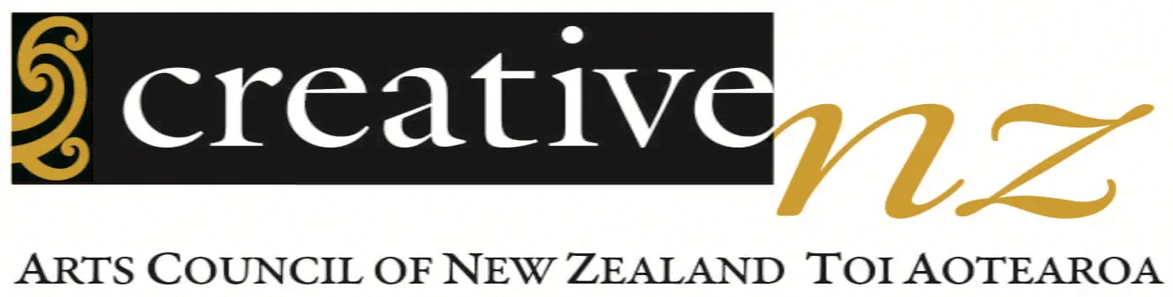
Name of nominee

Address
Email
Phone
Please mark the artforms that you have expertise in with an X:
 | Craft/Object Art |  |  |  | Dance |  | Inter-arts
 | Literature |  |  |  | Music |  | Ngā toi Māori
 | Pacific arts |  |  |  | Multi-artform (including film) |  | Theatre
 | Visual arts
What other skills or knowledge would you bring to the assessment committee eg assessment skills, knowledge of a particular community, art etc?

"A member of the community must nominate you for the Committee. Following consultation with the Mayor and elected member representative, a decision will be made. Upon confirmation of your appointment, you will receive an official notification and be invited to an initial meeting outlining the process.
Name of person making nomination

Email
Phone
Sign/Date

Please email your completed nomination form by 5pm, Sunday 12 Oct 2025 to ccs@southwaikato.govt.nz or drop in to SWDC Office building, 3 Torphin Cres Tokoroa – directed to Executive Office

